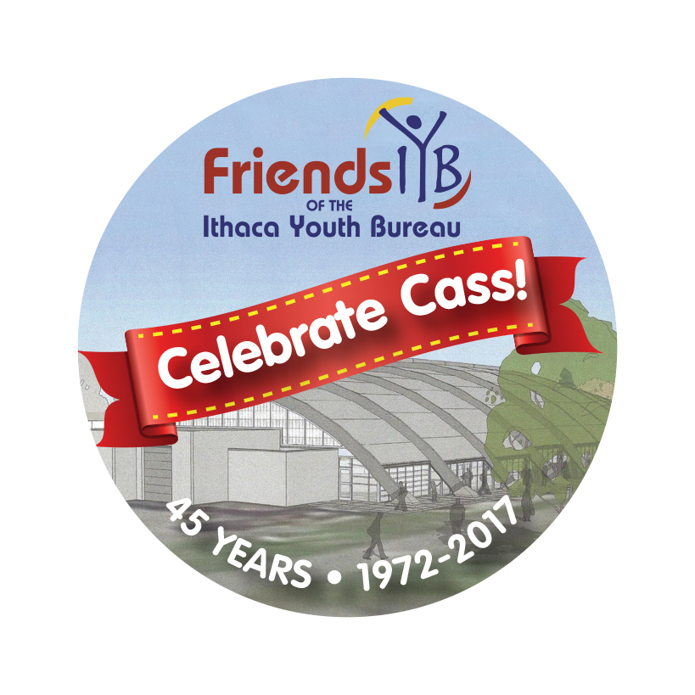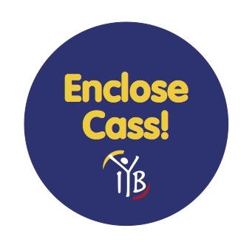
Enclose Cass Extravaganza!
Sun Nov 4 2:30-5:15
Skate-a-thon
Instructions for Skaters

Enclose Cass Extravaganza Skate-a-thon is a way for community members to help raise funds for the Cass Park Arena Enclosure Campaign while having fun and exercising!

How to collect donations:
Skaters of all ages can collect donations for the Skate-a-thon between now and November 4. Using the Sponsorship Form, ask your friends, family and neighbors to contribute because you are participating. They can donate for each lap you plan to skate, or for each hour, or another amount as they wish.

Collect the money at the time of donation and fill out the Sponsorship Form with the donor’s information, or use online forms found at www.friendsiyb.org/cass. Cash or checks (made out to Friends of IYB/Cass) can be submitted at Registration table on Nov. 4. Online works with major credit cards, and we’ll have a Square for onsite credit card gifts. Donations are tax deductible.

Youth who are seeking community service hours can get their forms signed if they are fully participating in the fundraiser and/or are volunteering to assist.

When? Where?
Come ready to skate! It’s being held at Cass Park during the regular Saturday public skating session from 2:30-5:15 pm. You can skate for all or part of the time. You will not be charged regular skating admission if you have collected a minimum donation of $25, but we hope you raise more for this fundraiser. Skates are available to rent for the standard fee.

The skater who raises the most money will win a Prize!

What else is happening on Nov. 4?
There’s something for everyone! Eat the Foood Truck sales will be benefitting the Cass Park Campaign from 12:00 noon-7:00 p.m. in the Parking Lot; beverages and baked goods will also be sold supporting the cause. Silent Auction will run 3:00-8:00 p.m. Skate-a-thon runs 2:30-5:15 p.m. before the Broomball Event from 5:30-10 p.m. All ages and ability levels can participate!

Anything Else? If you have any questions, visit www.friendsiyb.org/cass or email mmgithaca@gmail.com

These materials are neither sponsored nor endorsed by the Board of Education of the Ithaca City School District, the superintendent, or this school.

EMAIL ADDRESS  Please write neatly! | NAME &  HOME ADDRESS | DONATION AMOUNT
____________________________________  @__________________________________ | _____________________________________  _____________________________________  _____________________________________  _____________________________________ | $________
____________________________________  @__________________________________ | _____________________________________  _____________________________________  _____________________________________  _____________________________________ | $________
____________________________________  @__________________________________ | ______________________________________  ______________________________________  ______________________________________  ______________________________________ | $________
____________________________________  @__________________________________ | ______________________________________  ______________________________________  ______________________________________  ______________________________________ | $________

Skater Name: _______________________________________________
Checks should be made out to Friends of IYB/Cass
Please bring this form along with your donations to the Skate-a-thon
Or use online donation form at www.friendsiyb.org/cass

Friends of the Ithaca Youth Bureau is a non-profit 501c3 organization
Enclose Cass Extravaganza Skate-a-thon Sunday, Nov. 4
** All information must be provided to receive tax deduction letter **

