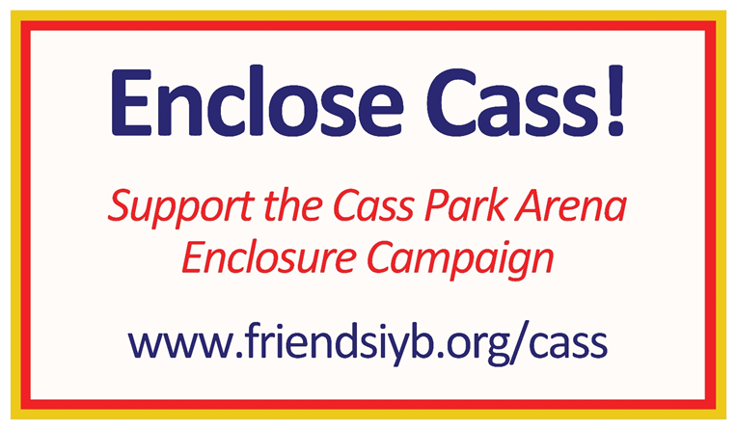
Doug’s Fish Fry Fundraiser

Saturday, Nov. 5 Enclose Cass Extravaganza!

11 am to 6 pm
Cass Park parking lot

PRE-ORDER: Complete form below and return by 11/2/16 to Doug’s Fish Fry c/o Mary Beth Ihnken, 281 76 Road, Brooktondale, NY 14817 with cash or credit card (no checks).
DAY of EVENT: Orders can be called in from 11am to 4pm at 607-423-5996 or you can order when you arrive. All Major Credit Cards accepted and Cash for Doug’s menu items.

Ithaca Youth Hockey Association, Tompkins Girls Hockey Association, Ithaca High Girls Varsity Hockey, and Ithaca High Boys Varsity Hockey, with Friends of the Ithaca Youth Bureau will host a Baked Goods and Beverage Sale (cash and checks written to Friends of IYB/Cass can be used to pay) to accompany the Doug’s orders (cash and credit card only). For more information, please email mbihnken@frontiernet.net

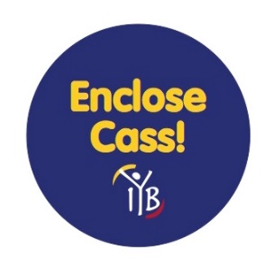

Fish Sandwich………$7.33 X _____=_____ Name:___________________________________
Fish Dinner.……..…$11.97 X _____=_____ Phone:___________________________________
Shrimp Only..……….$9.49 X _____=_____ Email:____________________________________
Shrimp Dinner…...…$14.13 X _____=_____ Total Cash: $___________Enclosed or pay by
Scallops Only………$12.10 X _____=_____ credit card (no checks)
Scallops Dinner….…$16.73 X _____=_____ CC#_____________ Ex Date:_____CVV#_____
Fresh Fries………...…$2.47 X _____=_____ Pickup @ Doug’s Food Truck
Cole Slaw……………$2.16 X _____=_____ Time:____________
ITEMS ARE FRIED IN 100% PEANUT OIL
Prices Include Tax
_________________________________________________________________________________________

PRE-ORDER with this form by 11/2/16

DAY of EVENT: 11/5/16, 11-6pm, Cass Park parking lot. Orders can be called in from 11am to 4pm at 607-423-5996 or you can order when you arrive. All Major Credit Cards accepted and Cash.

These materials are neither sponsored nor endorsed by the Board of Education
of the Ithaca City School District, the superintendent, or this school.

